**The Pizza Box**

# Introduction

The Pizza Box application provides the capability to place combo orders having pizza, side dishes and beverages items. This application allows the bill to be paid online or by cash. The delivery boy will then deliver the order.

# Requirements

1. User should be able to login.
2. After successful login, user should be able to place order and select a payment method – cash or card.
3. Once the order is ready it will be delivered to the user.

# Processing flow

## Core flow

1. On browsing to the pizzabox url the user will be directed to the homepage of the application.



1. When the user clicks on the login link, he will be redirected to the login page when he need to enter his username and password to proceed further. 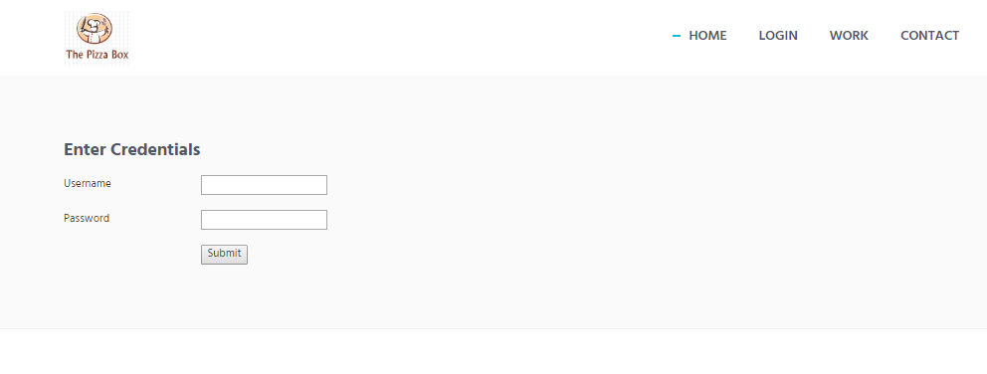
2. After successful login, user will be directed to the orders page where it can create an order. 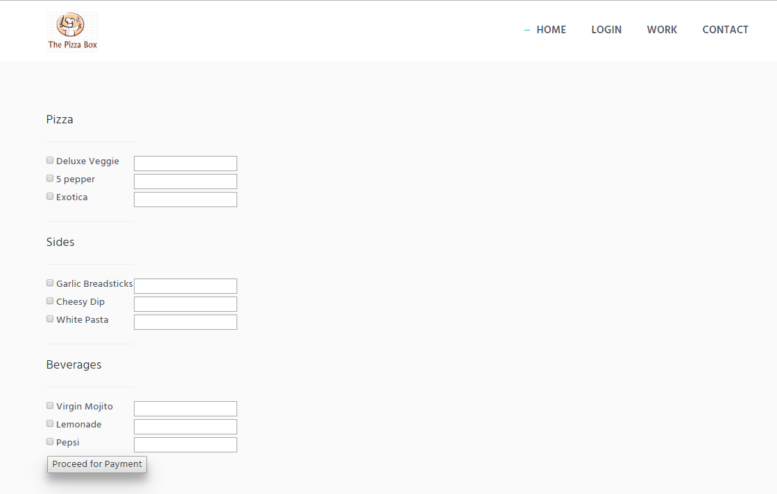

The user needs to select the checkbox corresponding to the item that he wants to order and enter the required quantity in the checkbox.

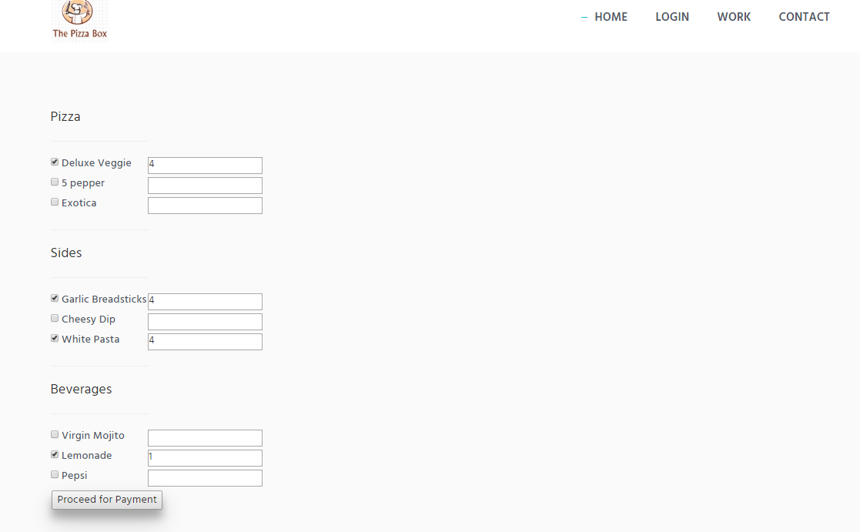

1. When the user clicks on ‘Proceed for Payment’ button he will be redirected to the order summary page where he can review his order the total amount to be paid and then click on ‘Proceed for checkout ’ button.

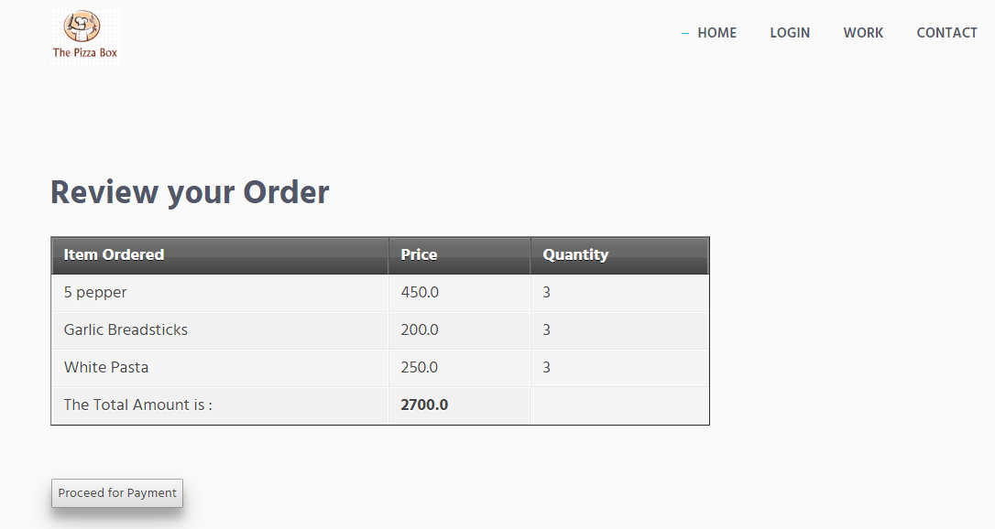

1. Paid orders are then picked up by the core-integration flow which will process the suborders independently.
2. These orders are in the ready state and are now ready to be picked up by the delivery system to get delivered.

## Payment flow

1. When user selects the online payment method, he will be redirected to a third party payment gateway and will return with success or error response.
2. This will cause an order to be in PAID or FAILED state.
3. User will be allowed to try again.

# Database Diagram

